C:\Visual identity\DesignersPack_2July2010\ArupBrandElements\Logo\ArupLogo2010_k.jpg

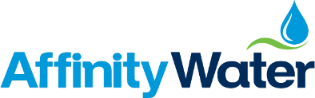

**Customer survey**

**Revised draft Water Resources**

**Management Plan (rdWRMP):**

**April 2019**

**Research report**

18-101134-01 | rdWRMP Customer survey | V3 INTERNAL CLIENT USE ONLY| This work was carried out in accordance with the requirements of the international quality standard for Market Research, ISO 20252, and the Ipsos Mori Terms and Conditions which can be found at http://www.ipsos-mori.com/terms.

Contents

[Executive Summary 3](#_Toc5893192)

[1 Introduction 4](#_Toc5893193)

[1.1 Background 4](#_Toc5893194)

[1.2 Methodology 4](#_Toc5893195)

[1.3 Interpretation of data 4](#_Toc5893196)

[2 Water consumption and affordability 5](#_Toc5893197)

[3 rdWMRP components 7](#_Toc5893198)

[3.1 Leakage reduction plans – customer support 8](#_Toc5893199)

[3.2 New reservoir plans – customer support 10](#_Toc5893200)

[3.3 Water usage reduction – customer support 12](#_Toc5893201)

[3.4 Drought reduction – customer support 14](#_Toc5893202)

[3.5 Canal transfer – customer support 17](#_Toc5893203)

[4 rdWRMP – acceptability 20](#_Toc5893204)

Executive Summary

* Ipsos MORI interviewed 1,000 Affinity Water customers aged 16+ through its online panel between 11-24 March 2019. The survey builds on two qualitative research projects – focus group discussions with customers – undertaken during December 2018-January 2019.
* The survey presented participants with several key propositions contained within the revised draft Water Resources Management Plan (rdWRMP). We included a bill impact alongside descriptions of *individual* propositions. The overlapping, inter-dependent nature of propositions, meant that it was not possible to itemise the specific impacts on bills of each proposition, so an overall bill impact was included. This did not account for inflation and the addition of sewerage services (which past research has shown can have an impact on customer views) but these were signposted as absent to participants
* The survey found high levels of support among customers for supply and demand-side propositions:
* Seven in ten, 70%, either *strongly* support or *tend to* support Affinity Water’s plans to take action to reduce leakage, including reducing leakage to between 11% and 13% by 2045.
* Two-thirds, 67%, support Affinity Water’s plans to take action to ensure there is enough water to supply to customers including building a new reservoir (the South East StrategicReservoir) by the late 2030s.
* A similar proportion, 65%, support plans to take action to reduce customer water usage including reducing usage to between 110 and 120 litres per person per day by 2045.
* Six in ten, 62%, support plans to take action to reduce drought including proposed investment in ways to help reduce the chance of drought happening from around 60% to around 25% over a 60-year period.
* Similarly, 59% of customers either strongly support or tend to support plans to transfer wastewater via canal from a wastewater treatment plant.
* In each case, support exceeds opposition by margins of at least five to one. Opposition does not exceed 12% - one in eight are cool on plans to take action on drought resilience - but around a fifth or more answer don’t know or say they have no views either way.
* These views are consistent across different groups of customers and geographies, although there are some differences (described throughout this report).
* Past surveys for Affinity Water putting draft clean water Business Plans to customers have found high levels of acceptability. This survey found 80% of customers either very accepting or fairly accepting of Affinity Water’s Water Resource Management Plan as a whole.
* Recent, more deliberative, qualitative research provides important context to these findings. Customers instincts tend towards being supportive of Affinity Water’s plans, shaped in part by broad satisfaction with the provision of clean water, and the prices they pay. This survey shows just 7% of customers reporting any difficulty paying their bills, while 64% think it possible they could cut their consumption.
* But there is low awareness of future challenges – customers call for more education and information – plus an ongoing need to build trust and credibility in terms of current provision, future plans, and performance against ambitions.

1. Introduction
   1. Background

Ipsos MORI was commissioned by Affinity Water to undertake survey research as part of a series of work being undertaken to measure and understand customer opinion and priorities in respect of the future management of water resources. Previous survey research – conducted in 2018 – collected customer opinion on a draft Water Resources Management Plan (dWRMP); this survey did the same for a rdWRMP.

* 1. Methodology

Ipsos MORI conducted an online survey of 1,000 Affinity Water customers aged 16+ between 11 and 24 March 2019. Customers were recruited to take part using the Ipsos MORI online survey panel. Recruitment and quotas targeted a representative sample of adults resident in Affinity Water’s eight service areas (WRZs – Water Resource Zones). The achieved sample profile and the effects of weighting are outlined in the Appendices of this report.

The survey was designed to provide a representative sample of customers across all areas served by Affinity Water. Consequently, the number of customers within each WRZ is proportional to the size of the population within each area, ranging from 52 participants in the Dour WRZ, 22 in Brett. As many of the regions have base sizes of under 100, they are not used for analysing the results of the survey.

* 1. Interpretation of data

Surveys generate estimates of the ‘truth’ which would only be available if a complete census of customers was undertaken. As a result, findings are subject to sampling tolerances and statistical confidence intervals, shown in the Appendices.

Survey data has been weighted to match the profile of the population living in Affinity Water areas by age and WRZ, based on 2011 Census data.

Where percentages and combinations – e.g. the percentage strongly support + tend to support – do not sum to 100, this is due to rounding of figures.

1. Water consumption and affordability

The survey began by asking customers about their water consumption habits to provide context for analysis of subsequent questions about support for a range of different demand and supply-side options.

**2.1 Water consumption**

While 56% of customers say they can cut their consumption through small reductions, 8% are confident of making big reductions. A further 33% say they are not able to use any less water they currently do.

* + - 1. Which if any, of these statements best fit your opinion of your household’s water consumption?



**2.2 Affordability**

Just over seven in ten (72%) customers report no difficulties in paying their overall water bill. A further 16% say they experience some difficulties in paying, but always pay on time. Much smaller proportions report difficulties, making late payments some of the time (6%) or all of the time (2%).

* + - 1. How easy or difficult do you find it to pay your current water bill?



Those in receipt of benefits are more likely to find paying water bills a struggle; just under half say they experience *no* problems (49%) a smaller proportion than among those who do *not* receive benefits (78%). The extent of difficulty in paying water bills varies by tenure; those who own their own homes are the most likely to say they have no problems paying their water bill (80%), while social and private renters are more likely to experience difficulties (just over half, 52%, report having no problems).

Table 2.1 below shows that the largest proportion of Affinity Water customers sampled across three surveys do not report having problems with paying bills (differences between surveys will reflect the methodologies used with the face-to-face survey having used additional quotas, including tenure and WRZ, and including customers who are offline).

* + - * 1. Affordability of bills – survey series

|  |  |  |  |
| --- | --- | --- | --- |
| ***How easy or difficult do you find it to pay your current water bill?*** | **March 2019**  *1,000 sample online (rdWRMP survey)* | **July 2018**  *1,000 sample online (Phase 3 Final Acceptability Survey* | **April – May 2018**  *825 sample face-to-face*  *(Business Plan  acceptability survey)* |
| I do not have problems paying my water bill | **72%** | 76% | 87% |
| It is difficult to pay my bill, but I always pay it on time | **16%** | 14% | 7% |
| It is difficult to pay my bill and I sometimes pay it late | **6%** | 4% | 3% |
| It is difficult to pay my bill and I never pay it on time | **2%** | 2% | 2% |
| Don’t know | **4%** | 4% | 1% |

1. rdWMRP components

The survey presented participants with several key components propositions contained within the rdWRMP. We included bill impacts for each *individual* proposition but did **not** account for inflation nor the addition of sewerage services.

Before being asked these questions, participants were presented with the following:

*We’d now like to ask you questions about Affinity Water’s plans for meeting their customers’ demands (how much water is needed) and how this will be supplied (how needs will be met).*

*Every five years, Affinity Water produces a Water Resources Management Plan. This looks at the amount of water that is available for supply and considers the impact of things like droughts, climate change and population growth, as well as changes in the way customers use water.*

*Here is some information to read before answering these questions.*

**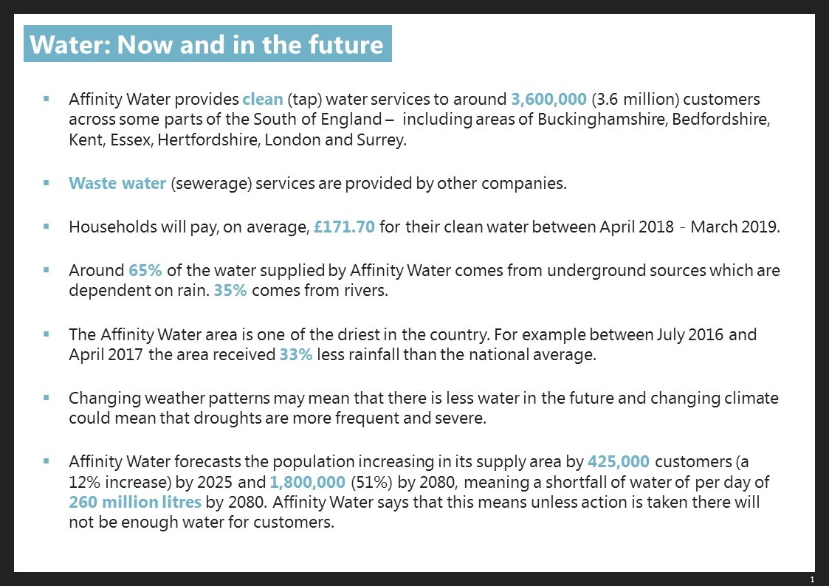**

The following sections describe customers’ responses to each proposition. They are ordered according to levels of support (highest first). In the survey we rotated the order in which propositions were presented to participants.

* 1. Leakage reduction plans – customer support

We described the plan to reduce leakage from 15% to between 11% and 13%:

*In 2015, leakage was around 21% (189 million litres) of the water Affinity Water put into supply. By 2025 this will have been reduced to 15%. Affinity Water is planning to reduce this to between 11% and 13% by 2045.*

*The reduction in leakage from 15% to between 11% and 13% would be part of Affinity Water’s Water Resources Management Plan and would add £0.37 to the average household bill for water supply every year until 2080. Currently, households pay on average £171.70 per year.*

*This does not include wastewater (sewerage) services, and £0.37 does not take inflation into account. Inflation is the rate of increase in prices for goods and services and Affinity Water expect a 2% increase each year due to inflation.*

*Please indicate the extent to which, in principle, you support or oppose Affinity Water taking this action to reduce leakage.*

This proposal was the most popular among those we tested. Seven in ten (70%) customers supporting it; 30% say they *strongly* support it and a further 40% say they tend to support it. This compares with 8% who are opposed; 5% tend to oppose and 3% strongly oppose.

Figure 3.1: Reduction in leakage – customer support



Support is broadly even across most customers as shown in Table 3.1. Older customers are more likely than average to be more positive though; 37% of 55-75-year olds saying they *strongly* support the proposition, compared with 28% of 16-34-year olds and 26% of 35-54-year olds.

* + - * 1. Reduction in leakage – support among groups of customers

|  |  |  |  |  |  |
| --- | --- | --- | --- | --- | --- |
| **Increase of £0.37 to average household bill)** | Strongly support | Tend to support | Tend to oppose | Strongly oppose | **Support** (strongly + tend to) |
| **Total** | **30%** | **40%** | **5%** | **3%** | ***70%*** |
| Male | 31% | 41% | 5% | 5% | ***72%*** |
| Female | 30% | 39% | 4% | 3% | ***70%*** |
| Aged 16-34 | 28% | 44% | 4% | 3% | ***72%*** |
| Aged 35-54 | 26% | 39% | 7% | 4% | ***65%*** |
| Aged 55+ | 37% | 37% | 4% | 3% | ***74%*** |
| Have Meter | 34% | 40% | 5% | 3% | ***75%*** |
| No meter | 28% | 40% | 4% | 3% | ***68%*** |
| White | 32% | 40% | 5% | 3% | ***71%*** |
| BME | 24% | 42% | 5% | 2% | ***66%*** |
| Main bill payer | 30% | 42% | 4% | 4% | ***72%*** |
| Not the main bill payer | 31% | 38% | 6% | 3% | ***69%*** |
| Benefits recipient | 37% | 36% | 1% | 3% | ***73%*** |
| Not a benefits recipient | 30% | 41% | 5% | 3% | ***71%*** |
| 1 – Misbourne\* | 39% | 35% | 5% | 2% | ***74%*** |
| 2 – Colne\* | 36% | 38% | 5% | 5% | ***75%*** |
| 3 – Lee | 25% | 42% | 4% | 3% | ***67%*** |
| 4 – Pinn | 28% | 43% | 4% | 2% | ***71%*** |
| 5 – Stort\* | 42% | 35% | 4% | 7% | ***77%*** |
| 6 – Wey | 22% | 46% | 5% | 5% | ***68%*** |
| 7 – Dour\* | 45% | 30% | 4% | 2% | ***76%*** |
| 8 – Brett\* | 28% | 22% | 15% | - | ***50%*** |

*Don’t mind/Don’t know/No views either way not shown.  
Figures that are significantly different to the overall population are underlined. Groups with \* are too small to be considered statistically robust.*

* 1. New reservoir plans – customer support

*Affinity Water proposes building a new reservoir in partnership with Thames Water so that it has enough water to supply to customers in the Affinity Water area in the years ahead.*

*Here is some more information about the proposed reservoir.*

*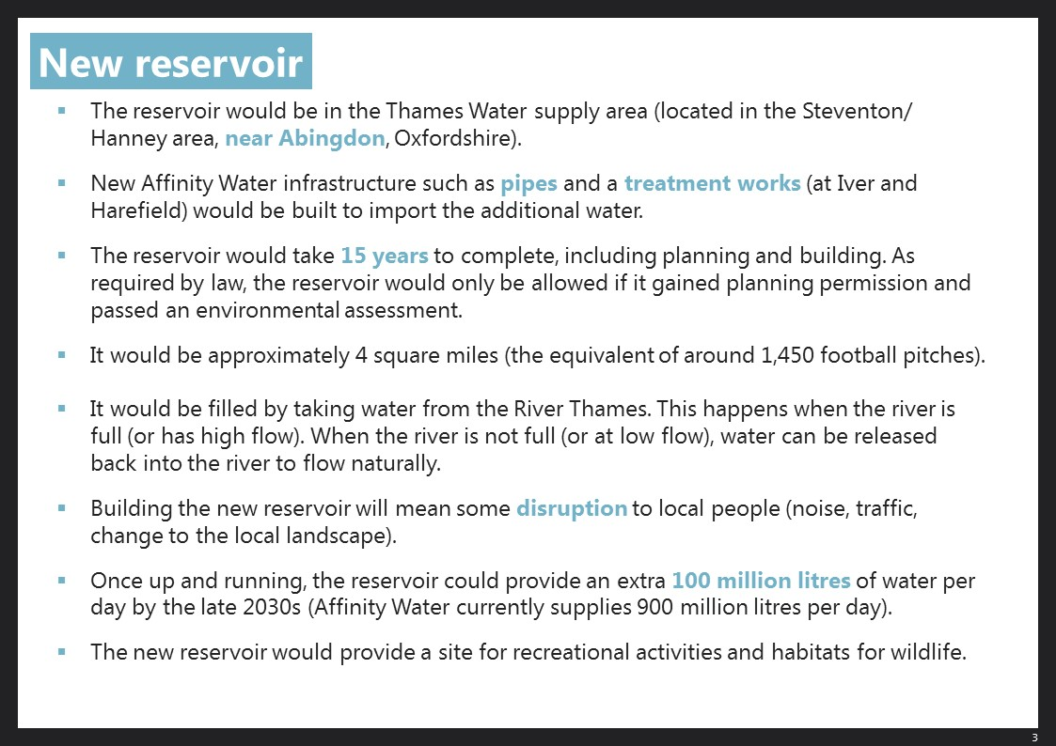*

*This would be part of the Water Resources Management Plan which would add £0.37 to the average household bill for water supply every year until 2080. Currently, households pay on average £171.70 per year.*

*This does not include wastewater services, and £0.37 does not take inflation into account. Inflation is the rate of increase in prices for goods and services and Affinity Water expect a 2% increase each year due to inflation.*

*Please indicate the extent to which, in principle, you support or oppose Affinity Water building a new reservoir.*

67% of customers support the plan to build a new reservoir, as described, to ensure there is enough water to supply to customers. A quarter, 25%, say they *strongly* support this and a further 43% tend to do so. In terms of opposition, 4% per cent say they tend to oppose it; 2% do so *strongly*.

* + - 1. New reservoir plans – customer support



* + - * 1. New reservoir plans – support among groups of customers

|  |  |  |  |  |  |
| --- | --- | --- | --- | --- | --- |
| **Increase of £0.37 to average household bill** | Strongly support | Tend to support | Tend to oppose | Strongly oppose | **Support** (strongly + tend to) |
| **Total** | **25%** | **43%** | **4%** | **2%** | ***67%*** |
| Male | 27% | 43% | 4% | 2% | ***70%*** |
| Female | 23% | 42% | 5% | 1% | **66%** |
| Aged 16-34 | 21% | 47% | 4% | 2% | ***67%*** |
| Aged 35-54 | 23% | 39% | 4% | 2% | ***62%*** |
| Aged 55+ | 30% | 43% | 6% | 1% | ***72%*** |
| Have Meter | 28% | 42% | 4% | 2% | ***70%*** |
| No meter | 23% | 43% | 5% | 2% | ***66%*** |
| White | 26% | 43% | 4% | 2% | ***69%*** |
| BME | 21% | 42% | 7% | 1% | ***63%*** |
| Main bill payer | 25% | 44% | 4% | 2% | ***69%*** |
| Not the main bill payer | 25% | 42% | 5% | 1% | ***67%*** |
| Benefits recipient | 33% | 37% | 4% | 1% | ***70%*** |
| Not a benefits recipient | 23% | 44% | 4% | 2% | ***67%*** |
| 1 – Misbourne\* | 28% | 37% | - | 4% | ***65%*** |
| 2 – Colne\* | 31% | 37% | 4% | 3% | ***68%*** |
| 3 – Lee | 22% | 48% | 5% | 1% | ***70%*** |
| 4 – Pinn | 23% | 44% | 5% | 2% | ***66%*** |
| 5 – Stort\* | 30% | 43% | 4% | 2% | ***73%*** |
| 6 – Wey | 21% | 45% | 4% | 1% | ***66%*** |
| 7 – Dour\* | 34% | 35% | 4% | 2% | ***68%*** |
| 8 - Brett\*\* | 17% | 39% | 13% | - | ***57%*** |

*Don’t mind/Don’t know/No views either way not shown.  
Figures that are significantly different to the overall population are underlined. Groups with \* are too small to be considered statistically robust.*

* 1. Water usage reduction – customer support

*Affinity Water is aiming towards reducing this to between 110 and 120 litres per person per day by 2045. They plan to do this by providing customers with more frequent information about their water use, free products and advice on how to reduce water usage, installing ‘smart’ water meters in homes, and working in partnership with Government, regulators and local organisations.*

*This action would be part of the Water Resources Management Plan which would add £0.37 to the average household bill for water supply every year until 2080. Currently, households pay on average £171.70 per year.*

*This does not include wastewater (sewerage) services, and £0.37 does not take inflation into account. Inflation is the rate of increase in prices for goods and services and Affinity Water expect a 2% increase each year due to inflation.*

*Please indicate the extent to which, in principle, you support or oppose Affinity Water taking this action to reduce water use.*

Over six in ten (65%) of customers support this. 22% say they *strongly* support this and a further 43% tend to do so. In terms of opposition, 11% per cent say they tend to oppose it; 4% do so *strongly*.

As with leakage reduction, support is fairly consistent across different groups of customers (shown in Table 3.2 below). One notable exception is 16-34-year olds; 72% of this group support the plan compared with 63% of 55-75-year olds and 61% of 35-54-year olds.

* + - 1. Water usage reduction – customer support



* + - * 1. Water usage reduction – support among groups of customers

|  |  |  |  |  |  |
| --- | --- | --- | --- | --- | --- |
| **Increase of £0.37 to average household bill** | Strongly support | Tend to support | Tend to Oppose | Strongly oppose | **Support** (strongly + tend to) |
| **Total** | **22%** | **43%** | **7%** | **4%** | ***65%*** |
| Male | 22% | 43% | 7% | 5% | ***65%*** |
| Female | 22% | 43% | 8% | 3% | ***65%*** |
| Aged 16-34 | 25% | 46% | 3% | 3% | ***72%*** |
| Aged 35-54 | 20% | 41% | 9% | 5% | ***61%*** |
| Aged 55+ | 21% | 41% | 9% | 4% | ***63%*** |
| Have Meter | 25% | 44% | 6% | 4% | ***69%*** |
| No meter | 20% | 42% | 9% | 4% | ***62%*** |
| White | 23% | 43% | 7% | 4% | ***66%*** |
| BME | 18% | 42% | 7% | 4% | ***60%*** |
| Main bill payer | 22% | 44% | 6% | 4% | ***66%*** |
| Not the main bill payer | 22% | 42% | 9% | 4% | ***64%*** |
| Benefits recipient | 33% | 39% | 4% | 1% | ***71%*** |
| Not a benefits recipient | 20% | 44% | 8% | 5% | ***64%*** |
| 1 – Misbourne\* | 17% | 38% | 11% | 2% | ***55%*** |
| 2 – Colne\* | 25% | 40% | 9% | 5% | ***65%*** |
| 3 – Lee | 22% | 47% | 7% | 2% | ***69%*** |
| 4 – Pinn | 22% | 43% | 7% | 3% | ***65%*** |
| 5 – Stort\* | 26% | 41% | 5% | 11% | ***67%*** |
| 6 – Wey | 16% | 49% | 5% | 6% | ***65%*** |
| 7 – Dour\* | 34% | 37% | 5% | 4% | ***71%*** |
| 8 – Brett\* | 19% | 31% | 9% | 2% | ***50%*** |

*Don’t mind/Don’t know/No views either way not shown.  
Figures that are significantly different to the overall population are underlined. Groups with \* are too small to be considered statistically robust.*

* 1. Drought reduction – customer support

*This question is about droughts. These can have an impact on the environment and may become more noticeable as they become more severe.*

*Currently, Affinity Water estimate that without taking action, there is around a 60% chance that at some point over the next 60 years they would need to use special measures including those shown here:*

*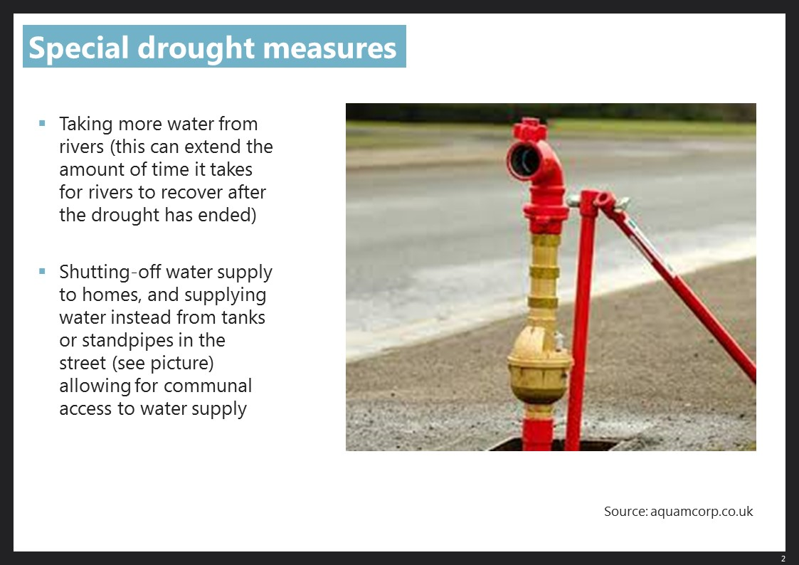*

*Affinity Water propose investing in ways to help reduce the chance of this happening from around 60% to around 25% over the 60-year period of the plan.*

*This action would be part of the Water Resources Management Plan which would add £0.37 to the average household bill for water supply every year until 2080. Currently, households pay on average £171.70 per year.*

*This does not include wastewater services, and £0.37 does not take inflation into account. Inflation is the rate of increase in prices for goods and services and Affinity Water expect a 2% increase each year due to inflation.*

*Please indicate the extent to which, in principle, you support or oppose Affinity Water taking this action on drought.*

Just over six in ten (62%) are supportive of plans to take action to reduce drought. 22% say they *strongly* support this and a further 40% tend to do so. 12% say they oppose Affinity Water’s plans; 8% tend to do so and 4% are *strong* opponents.

* + - 1. Drought reduction – customer support



In line with the propositions, support to take action to reduce drought is parallel across the different groups of customers (shown Table 3.4 below). There are a few significant exceptions, one of which, can be seen among benefit recipients who are more likely (30%) to *strongly* support the plan in comparison to those who are not (21%). Additionally, customers from an ethnic minority background are significantly less receptive to this plan, among whom 20% oppose the plan compared to just 11% of other customers.

* + - * 1. Drought reduction – support among groups of customers

|  |  |  |  |  |  |
| --- | --- | --- | --- | --- | --- |
| **Increase of £0.37 to average household bill** | Strongly support | Tend to support | Tend to Oppose | Strongly oppose | **Support** (strongly + tend to) |
| **Total** | **22%** | **40%** | **8%** | **4%** | ***62%*** |
| Male | 24% | 41% | 10% | 4% | ***66%*** |
| Female | 20% | 39% | 7% | 4% | ***59%*** |
| Aged 16-34 | 25% | 40% | 6% | 4% | ***65%*** |
| Aged 35-54 | 20% | 38% | 10% | 5% | ***58%*** |
| Aged 55+ | 21% | 42% | 8% | 3% | ***64%*** |
| Have Meter | 24% | 43% | 7% | 4% | ***67%*** |
| No meter | 21% | 39% | 9% | 4% | ***60%*** |
| White | 22% | 42% | 7% | 4% | ***64%*** |
| BME | 21% | 31% | 15% | 5% | ***53%*** |
| Main bill payer | 22% | 42% | 7% | 4% | ***64%*** |
| Not the main bill payer | 22% | 38% | 9% | 4% | ***60%*** |
| Benefits recipient | 30% | 35% | 6% | 5% | ***65%*** |
| Not a benefits recipient | 21% | 42% | 8% | 4% | ***62%*** |
| 1 – Misbourne\* | 21% | 43% | 7% | 5% | ***63%*** |
| 2 – Colne\* | 25% | 42% | 8% | 4% | ***67%*** |
| 3 – Lee | 22% | 36% | 7% | 4% | ***58%*** |
| 4 – Pinn | 23% | 36% | 8% | 5% | ***59%*** |
| 5 – Stort\* | 23% | 49% | 4% | 2% | ***72%*** |
| 6 – Wey | 19% | 42% | 12% | 5% | ***61%*** |
| 7 – Dour\* | 25% | 50% | 10% | 2% | ***75%*** |
| 8 – Brett\* | 15% | 35% | 11% | - | ***50%*** |

*Don’t mind/Don’t know/No views either way not shown.  
Figures that are significantly different to the overall population are underlined. Groups with \* are too small to be considered statistically robust.*

* 1. Canal transfer – customer support

*Affinity Water proposes transferring treated wastewater from a wastewater treatment plant near Birmingham – outside the Affinity Water area – so that it has enough water to supply to customers in the Affinity Water area in the years ahead.*

*Here is some more information:*

*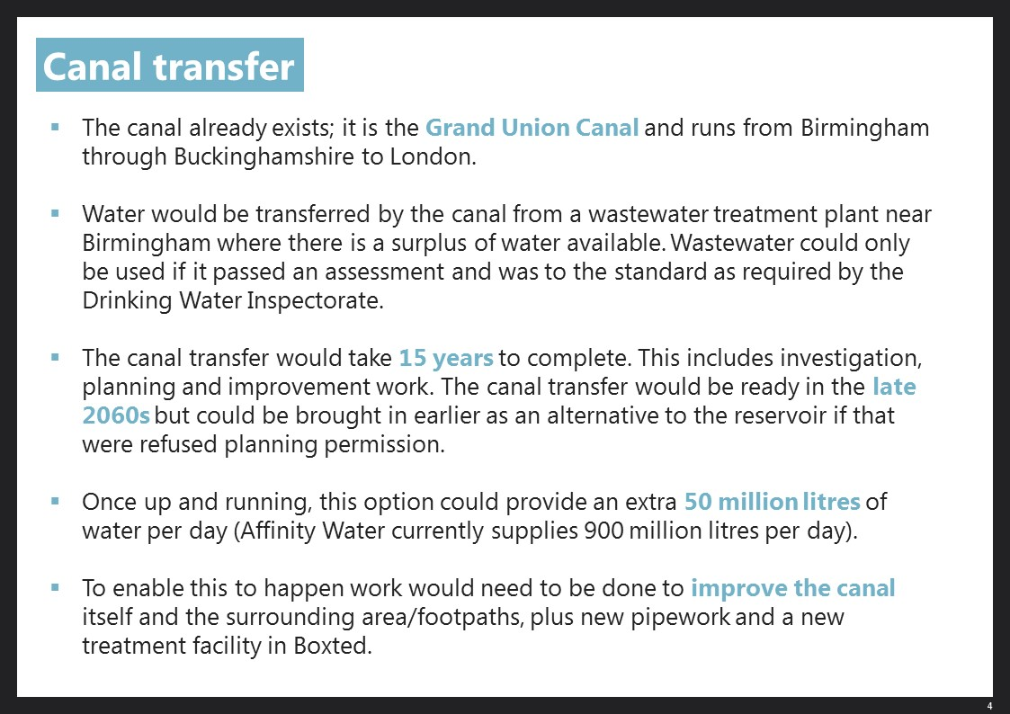*

*This would be part of the Water Resources Management Plan which would add £0.37 to the average household bill for water supply every year until 2080. Currently, households pay on average £171.70 per year.*

*This does not include wastewater services, and these figures do not take inflation into account. Inflation is the rate of increase in prices for goods and services and Affinity Water expect a 2% increase each year due to inflation.*

*Please indicate the extent to which, in principle, you support or oppose Affinity Water transferring treated wastewater by canal.*

The plan to transfer treated wastewater from a treatment plant via canal is relatively less popular among customers, but still, a clear majority, 59% support the plan. 20% *strongly* support it and an additional 40% tend to do so. In terms of opposition, 9% tend to oppose and 2% *strongly* oppose the plan.

* + - 1. Canal transfer – customer support



Support is consistent across the different groups (as shown in Table 3.5 below). However, customers within Colne (30%) are relatively more likely to *strongly* support this plan in comparison to users within the other seven WRZs.

* + - * 1. Canal transfer – support among groups of customers

|  |  |  |  |  |  |
| --- | --- | --- | --- | --- | --- |
| **Increase of £0.37 to average household bill** | Strongly support | Tend to support | Tend to Oppose | Strongly oppose | **Support** (strongly + tend to) |
| **Total** | **20%** | **40%** | **7%** | **2%** | ***59%*** |
| Male | 22% | 40% | 7% | 3% | ***62%*** |
| Female | 18% | 39% | 7% | 2% | ***57%*** |
| Aged 16-34 | 18% | 42% | 8% | 3% | ***60%*** |
| Aged 35-54 | 16% | 39% | 7% | 3% | ***55%*** |
| Aged 55+ | 25% | 38% | 6% | 2% | ***63%*** |
| Have Meter | 25% | 41% | 7% | 2% | ***65%*** |
| No meter | 16% | 40% | 7% | 3% | ***55%*** |
| White | 20% | 39% | 7% | 2% | ***60%*** |
| BME | 18% | 40% | 8% | 3% | ***58%*** |
| Main bill payer | 21% | 42% | 6% | 2% | ***63%*** |
| Not the main bill payer | 18% | 37% | 8% | 2% | ***56%*** |
| Benefits recipient | 25% | 38% | 8% | - | ***63%*** |
| Not a benefits recipient | 19% | 40% | 7% | 3% | ***59%*** |
| 1 – Misbourne\* | 24% | 37% | 8% | 2% | ***62%*** |
| 2 – Colne\* | 30% | 31% | 6% | 3% | ***61%*** |
| 3 – Lee | 16% | 39% | 5% | 2% | ***55%*** |
| 4 – Pinn | 21% | 45% | 4% | 3% | ***65%*** |
| 5 – Stort\* | 23% | 43% | 5% | 2% | ***66%*** |
| 6 – Wey | 14% | 37% | 14% | 3% | ***50%*** |
| 7 – Dour\* | 16% | 42% | 16% | 2% | ***58%*** |
| 8 – Brett\* | 9% | 39% | 4% | - | ***48%*** |

*Don’t mind/Don’t know/No views either way not shown.  
Figures that are significantly different to the overall population are underlined. Groups with \* are too small to be considered statistically robust.*

1. rdWRMP – acceptability

Having been asked about the different components of the rdWRMP, participants were asked about the rdWRMP as a whole:

*This next question looks at the Water Resources Management Plan as a whole.*

*Please take a minute to look at this outline of the Plan which includes the actions we’ve just asked you about.*

*Affinity Water’s Water Resources Management Plan would add £0.37 to the average household bill for water supply every year until 2080. This does not include wastewater (sewerage) services, and these figures do not take inflation into account. Inflation is the rate of increase in prices for goods and services and Affinity Water expect a 2% increase each year due to inflation.*

**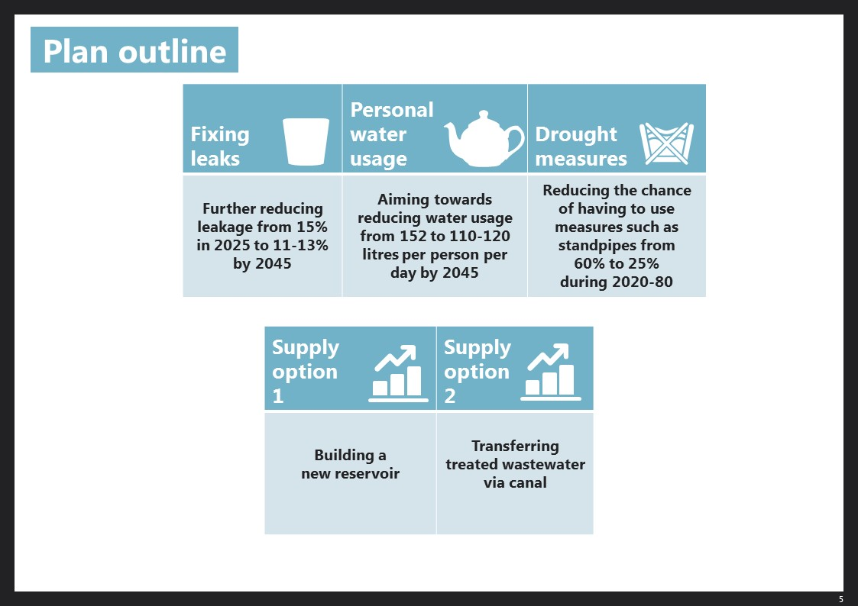**

*Overall, how acceptable or unacceptable do you think this Plan is?*

Eight in ten customers, 80%, consider Affinity Water’s Water Resource Management Plan, as described, to be acceptable – 25% consider it to be *very* acceptable, 55% *fairly* acceptable. Just 8% are negative; 6% consider the to be *not very* acceptable, 2% that it is *not at all* acceptable.

* + - 1. rdWRMP plan – acceptability

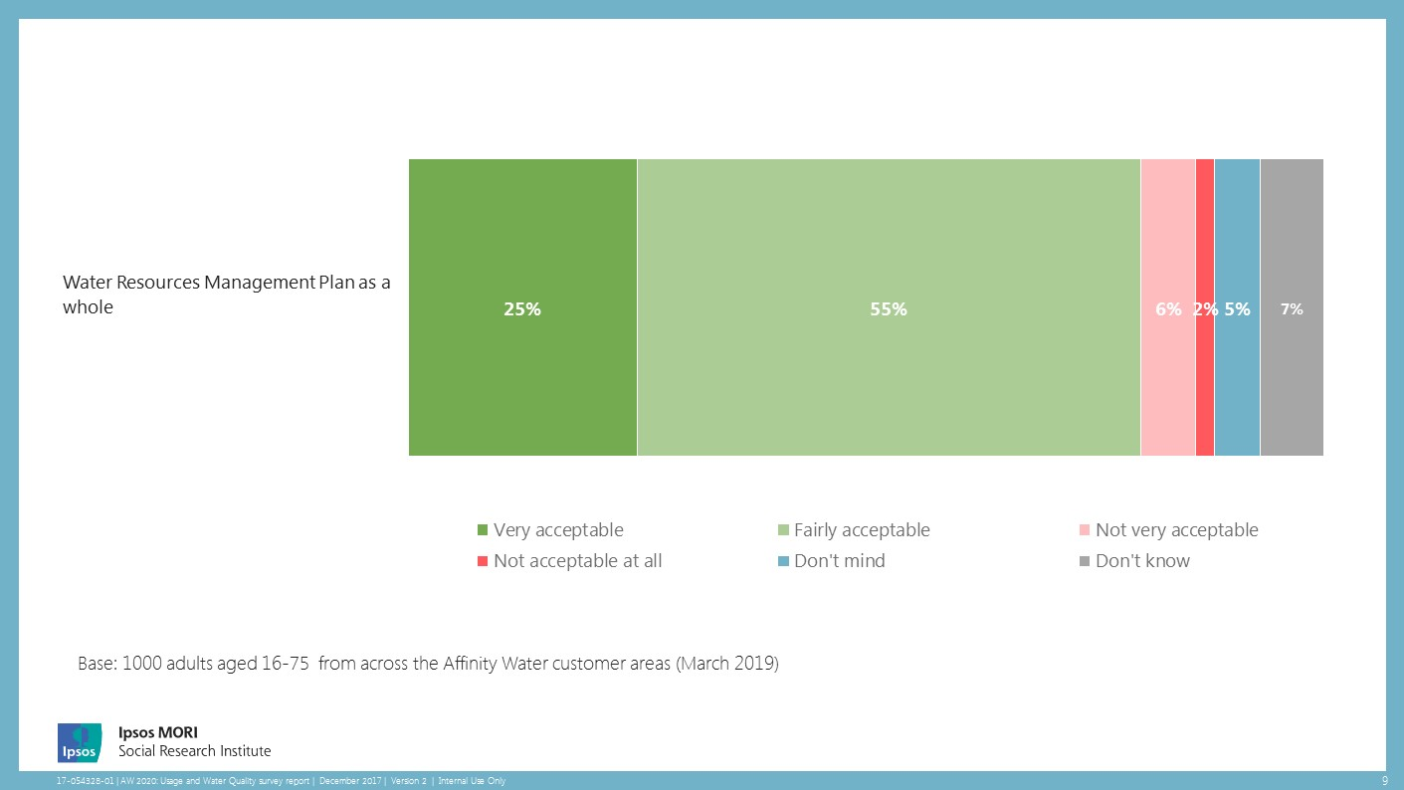

The 8% of participants who consider the plan *not very* acceptable or *not at all* acceptable were asked the main reasons for this They gave a variety of reasons. In several cases they attributed this to particular components of the plan, focusing in particular on leakage and PCC:

***“Leak reduction is not quick enough.”***

***“The targets are not ambitious.”***

***“I support most of the options - reducing usage, reservoir. Not at all keen on waste water recycling. Fixing leaks should be one of the main focus areas.”***

***“I dislike plans to control water consumption by households.”***

***“It’s too far-fetched. Restrictions on usage should be put in place sooner. Leakage is the first and foremost thing that should be dealt with and minimized to near 0%.”***

Some negativity seems to stem from a view that customer behaviour was at the heart of the reasons why the plan is necessary, and they should be made more responsible for their use of water:

***“I can't see anywhere that states water meters should be fitted in all properties. This would cut down on the amount of water used per household.”***

***“...They should make people responsible for their own consumption and do not build potentially damaging infrastructure.”***

***“… why should we pay extra when others don’t care about saving water, we are subsidising these people?”***

Several customers linked the plan being unacceptable to a view that the company rather than the customer should be making investments and funding improvement, particularly in the context of Affinity Water’s profits:

***“I oppose the idea that the customer has to pay for this plan.”***

***“Affinity make enough profit as it is and they should be using it for their plan anyway and costs should not be passed onto the customer…”***

***“I think we pay enough as it is and funds should be found from their own resources, not from the customers (again).”***

***“That should be standard from a water company, the public shouldn’t have to pay for this.”***

***“Why should cash-pressed households foot the cost of your assets acquisition?”***

Others expressed a concern about the impact on the affordability of their bills or their water use:

***“It’s a bit more for me.”***

***“The cost will be too high.”***

***“Our bill is already too high.”***

***“I cannot cut down any more on water usage.”***

Some customers felt unable to back the plan because of comprehension:

***“There’s not enough information.”***

***“I just would need to read more to understand it better and get my head around it. I don’t***

***really understand it.”***

***“I don't have enough information to ascertain what alternative options may be.”***

Table 4.2: rdWRMP – acceptability among groups of customers

|  |  |  |  |  |  |
| --- | --- | --- | --- | --- | --- |
| **Plan as a whole** | Very acceptable | Fairly acceptable | Not very acceptable | Not at all acceptable | **Acceptable** (very + fairly) |
| **Total** | **25%** | **55%** | **6%** | **2%** | ***80%*** |
| Male | 26% | 53% | 6% | 3% | ***80%*** |
| Female | 24% | 56% | 6% | 1% | ***80%*** |
| Aged 16-34 | 26% | 56% | 4% | 2% | ***82%*** |
| Aged 35-54 | 23% | 55% | 5% | 3% | ***78%*** |
| Aged 55+ | 26% | 54% | 8% | 1% | ***80%*** |
| Have Meter | 28% | 55% | 6% | 2% | ***84%*** |
| No meter | 23% | 54% | 7% | 2% | ***77%*** |
| White | 26% | 53% | 6% | 2% | ***80%*** |
| BME | 17% | 64% | 5% | 3% | ***81%*** |
| Main bill payer | 25% | 54% | 6% | 2% | ***80%*** |
| Not the main bill payer | 25% | 56% | 5% | 2% | ***81%*** |
| Benefits recipient | 34% | 48% | 5% | 1% | ***81%*** |
| Not a benefits recipient | 24% | 57% | 6% | 2% | ***80%*** |
| 1 – Misbourne\* | 31% | 51% | 7% | 2% | ***82%*** |
| 2 – Colne\* | 32% | 48% | 6% | 3% | ***80%*** |
| 3 – Lee | 22% | 60% | 5% | \* | ***82%*** |
| 4 – Pinn | 23% | 55% | 6% | 2% | ***78%*** |
| 5 – Stort\* | 30% | 52% | 4% | 4% | ***82%*** |
| 6 – Wey | 19% | 59% | 6% | 3% | ***78%*** |
| 7 – Dour\* | 26% | 57% | 4% | - | ***83%*** |
| 8 – Brett\* | 28% | 41% | 4% | - | ***69%*** |

*Don’t mind/Don’t know not shown.  
Figures that are significantly different to the overall population are underlined. Groups with \* are too small to be considered statistically robust.*

Participants were asked**Do you have any other comments or suggestions you would like to make about what Affinity Water’s proposals and Water Resources Management Plan?** For the most part, they answered ‘none’ or ‘no comments’ in response to this question but there were several themes (the following verbatims are included as illustrative of these but not necessarily commonly held views).

Many were positive about the plan and its intentions:

***“Action is going to be needed and it seems like you are on top of this. Nobody wants to run out of water.”***

***“I agree it is necessary to take steps now to prevent ameliorate problems in the future. I am glad they are thinking about the options and choices that need to be made.”***

***“Water is vital so is water management, I think we need to wake up to the fact that we NEED to pay far MORE for our water in the coming years. We take it far too much for granted. We need to treat it as the precious resource it is. We should support all and any methods to preserve it. Well done Affinity.”***

***“It's good to see that they are taking the issue seriously. The cost per household is negligible compared to the benefits possible.”***

There is a sense that Affinity Water is best placed to make decisions and also that delivery ought to be quicker:

***“I am assuming they know what they are doing as they are experts.”***

***“I think targets should be increased and the target time shortened.”***

***“Why aren't you doing this already?”***

***“I believe the canal transfer has been muted for many years – all talk and no do!”***

Support is often conditional on questions being answered or additional reassurances given:

***“Are there any provisions in the plan for vulnerable adults – for example, the disabled - who would find it impossible to use standpipes. Are there any problems with using Birmingham's waste water - do they always have a surplus?”***

***“I am broadly in support of finding ways to save water and avoid waste and leakage, but I have some doubts about the impact of introducing smart meters and creating a large reservoir.”***

***“I think there needs to be more research into household use...”***

Several customers highlighted the need for better information provision and Affinity Water enabling customers to use water more efficiently:

***“Customers need to be kept informed at all times and constantly reminded to use less water. With more and more homes being built and global warming the problems with water shortages will otherwise increase and be unmanageable.”***

***“Encourage households to use less water by showing them at every bill date how much their consumption is above a suitable point below the average (the average is currently too high in my opinion). Have incentives to use less water – e.g. cashback when usage is below the point described above.”***

***“People should be given tools and equipment so that they can save water and not waste.”***

The importance of efforts to reduce leakage is evident in comments from customers:

***“For heaven's sake, please prioritise resolving the issue of leakage. It is unreasonable to expect people to pay more or limit their water usage when so much water simply goes to waste via leaks. There is little visibility of Affinity's efforts regarding this, I would hope at least an annual statement showing a reduction target and what has been achieved (hopefully over-achieved) against said target. Thanks.”***

***“Fixing leaks is very important and forward planning is essential such as building a new reservoir or finding other sustainable water supplies.”***

***“Sort your own leak issues out before hounding customers about usage.”***

Comments also indicate some scepticism about delivery and motivations, and some unease about the prospect of additional price rises:

***“Affinity makes sufficient profits as things stand in my opinion.”***

***“Be more transparent about how Affinity Water itself intends to put more of its profits into infrastructure and not simply putting the financial burden upon us, your customers, by playing on our consciences and concerns for the community and environment. The absence of any questions about the use of profits, bonuses, remuneration and shareholder dividends is noticeable by its absence. Shame on you.”***

***“I can see why Ofwat gave you a poor mark. You keep trying to punish customers for your failures, just accept you will have to pay for this not customers. I know you don't like the idea, but tough.”***

***“Is it just me? I find it hard to believe that a change of 37p per household can bring about all these changes.”***

***“No comments except that 37p per household per annum is fair, however would not want to see this increase dramatically!”***



Appendices

**Appendix 1 – Customer profile**

The purpose of the survey was not to provide a profile of customers but rather to gather views from a range of Affinity Water customers. The participants took part in the survey online, from a sample that was sourced from Ipsos MORI’s online panel. This section provides an overview of the type of customers that took part in this survey, including demographic characteristics.

The sample of Affinity Water customers is predominantly made up of those who have the main responsibility for paying bills in their household. 55% are mainly responsible for paying their household bills, and a three in ten (30%) have joint-responsibility with other people. Thirteen per cent of the sample say they have no responsibility for paying bills.

**Figure 1: In general, who in your household is mostly responsible for paying water bills? This is probably the person(s) whose name is on the bill.**



Fewer than one in five of customers interviewed live in single person households (16%), and a third (35%) live in two-person households. The most common household size for Affinity Water customers is three or more people – half of the sample live in these larger households (46%).

**Figure 2: Thinking about where you live, how many people live there on a permanent basis?**



Slightly under half of customers interviewed reside within a property owned outright (45%), and one in three (29%) reside in a household being bought on a mortgage. One tenth (9%) of Affinity Water customers we surveyed rent from a local authority or housing association/trust.

**Figure 3: Which of the following best describes your home?**



As seen in figure 4 below, 53% of customers say they currently have a water meter in their household, compared with 42% who say they do not (6% are uncertain about whether they have a water meter or not).

**Figure 4: Do you have a water meter in your household?**



As shown in Figure 5, there is a comparable split between Affinity Water customers whose annual household income is between £16,106 and £39,999 as well as those who earn more than £40,000. Just over a tenth (13%) of all customers have an annual household income of £16,105 or less.

**Figure 5: Into which of the following bands does your annual household income fall, before tax and other deductions?**



70% say they know little or nothing about Affinity Water. While 55% say they do not know very much, a further 15%, say they know nothing at all. A fifth (21%) say they know a fair amount about the company but only 7% feel they know a great deal. These figures reflect others collected during the PR19 research programme.

Figure 6: How much, if anything, would you say you personally know about Affinity Water?



Younger customers are more likely than average to feel more well informed about Affinity Water, with 4 in 10 of 16-34-year olds saying they are at least somewhat aware of the business. This compares with just 24% of 35-54-year olds and 22% of 55-75-year olds. Familiarity is also significantly higher among men (37% know at least a fair amount, compared with 22% of women).

**Appendix 2 – Sample Profile**

|  |  |  |  |  |  |
| --- | --- | --- | --- | --- | --- |
| March 2019 | | Unweighted | | Weighted | |
| **N = 1,000** | | **Base** | **%** | **Base** | **%** |
| **Gender** | Male | 420 | 42% | 418 | 42% |
| Female | 580 | 58% | 582 | 58% |
| **Age** | Aged 16 - 34 | 242 | 24% | 297 | 30% |
| Aged 35 - 54 | 381 | 38% | 345 | 35% |
| Aged 55+ | 377 | 38% | 357 | 36% |
| **Tenure** | Home owner | 748 | 75% | 744 | 74% |
| Rented/other | 247 | 25% | 251 | 25% |
| **Meter status** | Yes | 520 | 52% | 528 | 53% |
| No | 425 | 43% | 415 | 42% |
| **Ethnicity** | White | 851 | 85% | 854 | 85% |
| BME | 136 | 14% | 134 | 13% |
| **Main bill payer** | Yes | 559 | 56% | 550 | 55% |
| No | 434 | 43% | 443 | 44% |
| **Benefits Recipient** | Yes | 151 | 15% | 152 | 15% |
| No | 819 | 82% | 818 | 82% |
| **Water Resource Zone** | WRZ 1 – Misbourne | 89 | 9% | 91 | 9% |
| WRZ 2 – Colne | 137 | 14% | 121 | 12% |
| WRZ 3 – Lee | 213 | 21% | 196 | 20% |
| WRZ 4 – Pinn | 293 | 29% | 268 | 27% |
| WRZ 5 - Stort | 56 | 6% | 80 | 8% |
| WRZ 6 – Wey | 138 | 14% | 153 | 15% |
| WRZ 7 – Dour | 52 | 5% | 52 | 5% |
| WRZ 8 - Brett | 22 | 2% | 39 | 4% |

**Appendix 3 – A guide to statistical reliability**

Ensuring that the survey results are statistically reliable is important when comparing the data between different years of the survey or between different groups within the sample to ensure that any differences are real (i.e. statistically significant). A sample size of 1,000 permits good level of analysis by key demographic variables (such as age, gender and work status).

This can be explained in the tables below. To illustrate, those who took part in the survey were only a sample of the total population of Affinity Water customers adults aged 16+, so we cannot be certain that the figures obtained are exactly those that would have been reached had everyone in the borough been interviewed (the ‘true’ values). We can, however, predict the variation between the sample results and the ‘true’ values from knowledge of the size of the samples on which the results to each question is based, and the number of times a particular answer is given. The confidence with which we can make this prediction is usually chosen to be 95% - that is, the chances are 95 in 100 that the ‘true’ value will fall within a specified range.

* + - * 1. Survey sampling tolerances: overall level

|  |  |  |  |
| --- | --- | --- | --- |
|  | Approximate sampling tolerances applicable to percentages at or near these levels | | |
| Size of sample on which survey result is based | 10% or 90% | 30% or 70% | 50% |
| 100 | 5.9 | 9.0 | 9.8 |
| 500 | 2.6 | 4.0 | 4.4 |
| 1,000 | **1.9** | **2.8** | **3.1** |
| 2,000 | 1.3 | 2.0 | 2.2 |

The following table indicates the sampling tolerances when comparing different groups of participants. If we once again assume a ‘95% confidence interval’, the differences between the results of two separate groups must be greater than the values given in the following table in order to be deemed ‘statistically significant’:

* + - * 1. Survey sampling tolerances: sub-group level

|  |  |  |  |
| --- | --- | --- | --- |
|  | Differences required for significance at or near these percentage levels | | |
| Size of sample on which survey result is based | 10% or 90% | 30% or 70% | 50% |
| 100 vs.100 | 8.4 | 12.8 | 13.9 |
| 300 vs. 300 | 4.8 | 7.3 | 8.0 |
| 473 vs. 527 (males vs. females) | 3.7 | 5.7 | 6.2 |
| 1,000 vs. 1,000 (this survey compared to the 2018 dWRMP survey) | 2.6 | 4.0 | 4.4 |

For example, if 46% of male customers give a particular answer compared with 54% of female ones (assuming sample sizes in the table above), then the chances are 19 in 20 that this eight-point difference is significant (as the difference is more than 6.2 percentage points)

It is important to note that, strictly speaking, the above confidence interval calculations relate only to samples that have been selected using strict probability sampling methods. However, in practice it is reasonable to assume that these calculations provide a good indication of the confidence intervals relating to this survey.

**Appendix 4 - Survey questionnaire**

**18-101134-01 Affinity Water rdWRMP Survey**

**Affinity Water provides clean (tap) water services to around 3.6 million customers across some parts of the South of England – including areas of Buckinghamshire, Bedfordshire, Kent, Essex, Hertfordshire, London and Surrey. The wastewater (sewerage) services for these areas are provided by separate companies.**

**In this survey, we want to ask about you and your household’s use of water and about Affinity Water’s long-term plans, 2020 to 2080 and the estimated cost for customers.**

**Please click below to get started…**

**ASK ALL - SA**

**STANDARD GENDER CORTEX MODULE FOR UK**

**ASK ALL – SA**

**STANDARD AGE CORTEX MODULE**

**SCREEN OUT IF AGE<16**

**RECODE AGE IN QUOTAGERANGE AS FOLLOWS:**

1. 16-24 [16-24 yo]
2. 25-34 [25-34 yo]
3. 35-54 [35-54 yo]
4. 55-99 [55- 99 yo]

**ASK ALL – SA**

**STANDARD MARKET SIZE CORTEX MODULE**

**(uk region)**

**Q1. We’d like to ask a few questions first to ensure we are talking to a wide range of people. Which of the following best describes your home?**

**ASK ALL. SA. RANDOMISE CODES 1-5.**

1. Being bought on a mortgage

2. Owned outright by household

3. Rented from Local Authority

4. Rented from Housing Association / Trust

5. Rented from private landlord

6. Other

7. Don’t know

**EU01EMP.** **What is your current employment status?   
ASK ALL. SA.**

**< Please select one option >**

\_1 Employed full-time (35 hours or more a week)

\_2 Employed part-time

\_3 Self employed

\_4 Unemployed but looking for a job

\_5 Unemployed and not looking for a job/Long-term sick or disabled

\_6 Looking after the home/family

\_7 Retired

\_8 Student/Pupil/In full time education

RECODE EU01EMP IN WORKSTATUS AS FOLLOWS:

IF EU01EMP=1 then WORKSTATUS=1. Full time employment

IF EU01EMP=2 OR 3 OR 3 OR 4 OR 5 OR 6 OR 7 OR 8 then WORKSTATUS=2. Not full-time employment

**Q2. Which of these best describes your ethnic group?**

**ASK ALL. SA.   
RECODE Q2 TO ETHNICITY (IF Q2 = 1 OR 2 OR 3 OR 4 => ETHNICITY=1. White; IF Q2=5 - 19 => ETHNICITY=2. BME).**

WHITE

1. White – English / Welsh / Scottish / Northern Irish / British

2. White – Irish

3. White – Gypsy or Irish Traveller

4. Any other White background

MIXED

5. Mixed White and Black Caribbean

6. Mixed White and Black African

7. Mixed White and Asian

8. Any other mixed background

ASIAN

9. Asian or Asian British – Indian

10. Asian or Asian British – Pakistani

11. Asian or Asian British – Bangladeshi

12. Asian or Asian British – Chinese

13. Any other Asian/Asian British background

BLACK

14. Black or Black British – Caribbean

15. Black or Black British – African

16. Any other Black/Black British background

OTHER ETHNIC GROUP

17. Arab

18. Any other ethnic group

19. Prefer not to say

**SCREENER END - NEW PAGE:**

**To start with, we’d like to ask you a few questions about your use of water and Affinity Water, the water company in your local area who provide clean (tap) water.**

**NEW PAGE:**

**Q3.** **Which, if any, of these statements best fits your opinion of your household’s water consumption?**

**ASK ALL. SA.**

1. I don’t think our household can use less water than we do now
2. I think we might be able to make a small reduction in our household’s water consumption
3. We probably could make big reductions in our household’s water consumption
4. Don’t know

**Q4. How easy or difficult do you find it to pay your current water bill? We are interested in your TOTAL water bill overall, that is including CLEAN (tap) water services provided by Affinity Water and WASTE (sewerage) water services provided by a separate company.**

**ASK ALL. SA.**

**ROTATE OPTIONS 1-4.**

1. I do not have problems paying my water bill
2. It is difficult to pay my bill but I always pay it on time
3. It is difficult to pay my bill and I sometimes pay it late
4. It is difficult to pay my bill and I never pay it on time
5. Don’t know

**Q5. How much, if anything, would you say you personally know about Affinity Water?**

**ASK ALL. SA.**

**ROTATE ANSWER CODES 1-4.**

1. A great deal
2. A fair amount
3. Not very much
4. Nothing at all
5. Don’t know

**We’d now like to ask you questions about Affinity Water’s plans for meeting their customers’ demands (how much water is needed) and how this will be supplied (how needs will be met).**

**Every five years, Affinity Water produces a Water Resources Management Plan. This looks at the amount of water that is available for supply and considers the impact of things like droughts, climate change and population growth, as well as changes in the way customers use water.**

**Here is some information to read before answering these questions.**

****

**The next few questions ask you the extent to which you support or oppose a number of actions Affinity Water intends to include in its Water Resources Management Plan for the period up to 2080. You will then be asked about Affinity Water’s Water Resources Management Plan as a whole.**

**The estimated increases in bills we show, are for the WHOLE Water Resources Management Plan not the individual actions. They are also only for the part of customers’ bills that relate to water resources. Whether bills increase more than this will depend on what else Affinity Water has to do to provide good quality drinking water to you.**

**ROTATE QUESTION ORDER WITHIN 2 BLOCKS - Q6-Q8 AND Q9-Q10**

**ALLOW PARTICIPANT THE OPTION OF SNAPPING BACK TO QUESTIONS AND CHANGING THEIR ANSWERS**

**NEW PAGE:**

**Q6.**  **This question is about water leakage. To tackle this, Affinity Water must consider the cost of finding and repairing leaking pipes (and the impact on traffic disruption) compared to the cost of producing and delivering water from other sources.**

**In 2015, leakage was around 21% (189 million litres) of the water Affinity Water put into supply. By 2025 this will have been reduced to 15%. Affinity Water is planning to reduce this to between 11% and 13% by 2045.**

**The reduction in leakage from 15% to between 11% and 13% would be part of Affinity Water’s Water Resources Management Plan and would add £0.37** **to the average household bill for water supply every year until 2080. Currently, households pay on average £171.70 per year.**

**This does not include wastewater (sewerage) services, and £0.37** **does not take inflation into account. Inflation is the rate of increase in prices for goods and services and Affinity Water expect a 2% increase each year due to inflation.**

**Please indicate the extent to which, in principle, you support or oppose Affinity Water taking this action to reduce leakage.  
ASK ALL. SA.**

1. Strongly support
2. Tend to support
3. No views either way
4. Tend to oppose
5. Strongly oppose
6. Don’t mind
7. Don’t know

**Q6a. What are the main reasons you oppose taking this action to reduce leakage?**

**ASK IF Q6= 4 OR 5. FREE TEXT BOX.**

**Q7. This question is about the amount of water used by customers.**

**At present, Affinity Water’s customers use an average of 152 litres per person per day** **compared to** **the national average of** **141** **litres.**

**Affinity Water is aiming towards reducing this to between** **110 and 120 litres per person per day by 2045. They plan to do this by providing customers with more frequent information about their water use, free products and advice on how to reduce water usage, installing ‘smart’ water meters in homes, and working in partnership with Government, regulators and local organisations.**

**This action would be part of the Water Resources Management Plan which would add £0.37** **to the average household bill for water supply every year until 2080. Currently, households pay on average £171.70 per year.**

**This does not include wastewater (sewerage) services, and £0.37 does not take inflation into account. Inflation is the rate of increase in prices for goods and services and Affinity Water expect a 2% increase each year due to inflation.**

**Please indicate the extent to which, in principle, you support or oppose Affinity Water taking this action to reduce water use.  
ASK ALL. SA.**

1. Strongly support
2. Tend to support
3. No views either way
4. Tend to oppose
5. Strongly oppose
6. Don’t mind
7. Don’t know

**Q7a. What are the main reasons you oppose taking this action to reduce water use?**

**ASK IF Q7= 4 OR 5. FREE TEXT BOX.**

**Q8. This question is about droughts. These can have an impact on the environment and may become more noticeable as they become more severe.**

**Currently, Affinity Water estimate that without taking action, there is around a 60% chance that at some point over the next 60 years they would need to use special measures including those shown here:**

****

**Affinity Water propose investing in ways to help reduce the chance of this happening from around 60% to around 25% over the 60-year period of the plan.**

**This action would be part of the Water Resources Management Plan which would add £0.37** **to the average household bill for water supply every year until 2080. Currently, households pay on average £171.70 per year.**

**This does not include wastewater services, and £0.37 does not take inflation into account. Inflation is the rate of increase in prices for goods and services and Affinity Water expect a 2% increase each year due to inflation.**

**Please indicate the extent to which, in principle, you support or oppose Affinity Water taking this action on drought.  
ASK ALL. SA.**

1. Strongly support
2. Tend to support
3. No views either way
4. Tend to oppose
5. Strongly oppose
6. Don’t mind
7. Don’t know

**Q8a. What are the main reasons you oppose taking this action on drought?**

**ASK IF Q8= 4 OR 5. FREE TEXT BOX.**

**These next questions are about proposals to increase the supply of water to meet extra demand in the future.**

**Q9. Affinity Water proposes building a new reservoir in partnership with Thames Water** **so that it has enough water to supply to customers in the Affinity Water area in the years ahead.**

**Here is some more information about the proposed reservoir.**

****

**This would be part of the Water Resources Management Plan which would add £0.37** **to the average household bill for water supply every year until 2080. Currently, households pay on average £171.70 per year.**

**This does not include wastewater services, and £0.37 does not take inflation into account. Inflation is the rate of increase in prices for goods and services and Affinity Water expect a 2% increase each year due to inflation.**

**Please indicate the extent to which, in principle, you support or oppose Affinity Water building a new reservoir?  
ASK ALL. SA.**

1. Strongly support
2. Tend to support
3. No views either way
4. Tend to oppose
5. Strongly oppose
6. Don’t mind
7. Don’t know

**Q9a. What are the main reasons you oppose building a new reservoir?**

**ASK IF Q9= 4 OR 5. FREE TEXT BOX.**

**NEW PAGE:**

**Q10. Affinity Water proposes transferring treated wastewater from a wastewater treatment plant outside the near Birmingham – outside the Affinity Water area – so that it has enough water to supply to customers in the Affinity Water area in the years ahead.**

**Here is some more information:**

****

**This would be part of the Water Resources Management Plan which would add £0.37** **to the average household bill for water supply every year until 2080. Currently, households pay on average £171.70 per year.**

**This does not include wastewater services, and these figures do not take inflation into account. Inflation is the rate of increase in prices for goods and services and Affinity Water expect a 2% increase each year due to inflation.**

**Please indicate the extent to which, in principle, you support or oppose Affinity Water transferring treated wastewater by canal.  
ASK ALL. SA.**

1. Strongly support
2. Tend to support
3. No views either way
4. Tend to oppose
5. Strongly oppose
6. Don’t mind
7. Don’t know

**Q10a. What are the main reasons you oppose Affinity Water transferring treated wastewater by canal?**

**ASK IF Q10= 4 OR 5. FREE TEXT BOX.**

**NEW PAGE:**

**Q11. This next question looks at the Water Resources Management Plan as a whole.**

**Please take a minute to look at this outline of the Plan which includes the actions we’ve just asked you about.**

**Affinity Water’s Water Resources Management Plan would add £0.37** **to the average household bill for water supply every year until 2080. This does not include wastewater (sewerage) services, and these figures do not take inflation into account. Inflation is the rate of increase in prices for goods and services and Affinity Water expect a 2% increase each year due to inflation.**

****

**Overall, how acceptable or unacceptable do you think this Plan is?**

**ASK ALL. SA.**

1. Very acceptable
2. Fairly acceptable
3. Not very acceptable
4. Not acceptable at all
5. Don’t mind
6. Don’t know

**Q11a. What are the main reasons why you find the Plan not very or not at all acceptable?**

**ASK IF Q11= 3 OR 4. FREE TEXT BOX.**

**NEW PAGE:**

**ASK ALL. FREE TEXT**

**Q12. Do you have any other comments or suggestions you would like to make about what Affinity Water’s proposals and Water Resources Management Plan?**

**NEW PAGE:**

**To finish off, now for some final questions about you and your household.**

**Q13. Do you have a water meter in your household?**

***Properties with a water meter pay for the water they use, and those that do not pay the same amount regardless of water usage***

**ASK ALL. SA.**

1. Yes, we have a water meter in our household
2. No, we do not have a water meter in our household
3. Not sure

**Q14. Thinking about where you live, how many people live there on a permanent basis? Please include yourself and all children of any age.**

**ASK ALL. NUMERIC. ENTER NUMBER 1-99.**

1. Don’t know

**Q15.** **In general,** **who in your household is mostly responsible for paying water bills? This is probably the person(s) whose name is on the bill.**

**ASK ALL. SINGLE CODE.**

1. Mostly me
2. Jointly me and others
3. Other people – in household
4. Other people – not in household
5. Don’t know

**Q16. Do you have any long-term illness, health problems or disability which limits your daily activities or the work you can do, including any problems which are due to old age?**

**ASK ALL. SA.**

1. Yes – I do
2. No – I do not
3. Don’t Know/Prefer not to say

**Q17. Do you, or anyone in your household, currently receive any Government benefits? These include things like Universal Credit, Job Seekers Allowance, Income Support, Housing Benefit and Tax Credits.   
ASK ALL. SA.**

1. Yes
2. No
3. Don’t Know/Prefer not to say

**Q18. Into which of the following bands does your annual household income fall, before tax and other deductions?   
ASK ALL. SA.**

|  |  |
| --- | --- |
| **Per MONTH** | **Per YEAR** |
| * + - 1. £541 or less | £6,499 or less |
| * + - 1. £542 to £791 | £6,500 to £9,499 |
| * + - 1. £792 to £1,342 | £9,500 to £16,105 |
| * + - 1. £1,343 to £2,083 | £16,106 to £24,999 |
| * + - 1. £2,084 to £3,333 | £25,000 to £39,999 |
| * + - 1. £3,334 to £4,999 | £40,000 to £59,999 |
| * + - 1. £5,000 to £6,249 | £60,000 to £74,999 |
| * + - 1. £6,250 and over | £75,000 and over |
| * + - 1. Don’t know | Don’t know |
| * + - 1. Refused | Refused |

**On behalf of Ipsos MORI and Affinity Water, thank you for taking part in our survey.**

**Thank and close.**

**Ben Marshall**  
Research Director

**Teodros Gebrekal**   
Research Executive

**Imogen Drew**  
Research Executive

For more information

3 Thomas More Square  
London  
E1W 1YW

t: +44 (0)20 3059 5000

**www.ipsos-mori.com  
http://twitter.com/IpsosMORI**

**About Ipsos MORI’s Social Research Institute**The Social Research Institute works closely with national governments, local public services and the not-for-profit sector. Its c.200 research staff focus on public service and policy issues. Each has expertise in a particular part of the public sector, ensuring we have a detailed understanding of specific sectors and policy challenges. This, combined with our methods and communications expertise, helps ensure that our research makes a difference for decision makers and communities.